**AUTONOMOUS ELECTRONIC GUIDING STICK USING IoT FOR THE VISUALLY CHALLENGED**

## A PROJECT REPORT

### *Submitted by*

|  |  |
| --- | --- |
| **ARSHIYA TABASUM G** | **412816107010** |
| **KRITHIGA R** | **412816107043** |
| **LAKSHMI R** | **412816107044** |
| **LALITHAPRIYA A** | **412816107045** |

***in partial fulfillment for the award of the degree of***

**BACHELOR OF ENGINEERING**

***in***

## ELECTRONICS AND INSTRUMENTATION ENGINEERING



**SRM VALLIAMMAI ENGINEERING COLLEGE (AN AUTONOMOUS INSTITUTION) CHENGALPATTU**

**ANNA UNIVERSITY :: CHENNAI 600 025**

**APRIL 2020**

# ANNA UNIVERSITY: CHENNAI 600 025

**BONAFIDE CERTIFICATE**

Certified that this project report **“AUTONOMOUS ELECTRONIC GUIDING STICK USING IoT FOR THE VISUALLY CHALLENGED”** is the bonafide work of “**ARSHIYA TABASUM G (412816107010), KRITHIGA R (412816107043), LAKSHMI R (412816107044), LALITHAPRIYA A**

**(412816107045)** who carried out the project work under my supervision.

**SIGNATURE SIGNATURE**

Dr S. VISALAKSHI M.E., Ph.D., Dr. S.C. PRASANNA M.E., Ph.D.,

**HEAD OF THE DEPARTMENT SUPERVISOR**

Assistant Professor (Sel. G)

Department of Electronics and Department of Medical Electronics Instrumentation Engineering

SRM Valliammai Engineering College SRM Valliammai Engineering College (An Autonomous Institution), (An Autonomous Institution),

SRM Nagar, SRM Nagar,

Kattankulathur – 603 203. Kattankulathur – 603 203.

Submitted for viva-voce examination held on at SRM Valliammai Engineering College, Kattankulathur – 603 203.

## INTERNAL EXAMINER EXTERNAL EXAMINER

**ACKNOWLEDGEMENT**

Completion of this project has been a shared achievement for which we are indebted to many people. We express our thanks to **Dr.T.R. PAARIVENDAR**, the chairman of our college for the opportunities he has provided us with to finish the project.

We are grateful to our principal **Dr.B.CHIDHAMBARA RAJAN, M.E., Ph.D.,** who has served as a great source of inspiration for us in carrying out the project.

We also extend our sincere respect to our vice principal **Dr.M.MURUGAN, M.E., Ph.D.,** who motivated us in carrying out the project. We would like to extend our heartfelt respect to our beloved professor and Head of the Department **Dr.S.VISALAKSHI M.E., Ph.D.**, for giving us constant support throughout our project.

We would like to thank our project coordinators **Mr.B.PARAMESHWARAN M.E.,** Assistant Professsor (O.G) and **Ms.K.S.JAIBHAVANI M.Tech (Ph.D),** Assistant Professor (O.G) for assistance in completion of the project.

With respect, express our sincere gratitude to our project guide **Dr.S.C.PRASANNA M.E., Ph.D.,** Assistant professor (Sel.G) for guiding us throughout the project.

We would like to thank all our teaching and non-teaching staffs for their help and cooperation. Last but not the least, we sincerely thank our parents without whose love, support and cooperation we would not have finished our project successfully.

## ABSTRACT

Navigating from one place to other is one of the fundamental actions performed in man’s life. Visually challenged people face so many problems in navigation and they are often dependent on traditional walking sticks, guide dogs or guides. With increasing human machine interaction, there are lots of devices which help in navigation of the visually challenged in indoor and outdoor environments. The most preferred guiding solution by the blind is the walking cane. Guides and guide dogs can turn out to be an expensive option. Therefore, we aim to design and implement a low cost, real time navigation system which is the guiding electronic stick that assists these visually challenged people in their navigation by audio instructions and can autonomously move which resembles the traditional walking cane.

**சாராம்சம்**

ஒரு இடத்தில் இருந்து இன்ன ொரு இடத்திற்குச் னெல்வது மனிதனின்

வொழ்க்கையில் நிைழ்த்தப்படும்

அடிப்பகட னெயல்ைளில் ஒன்றொகும். பொர்கவ

ெவொலொ மக்ைள் வழினெலுத்தலில் பல சிக்ைல்ைகை எதிர்னைொள்கின்ற ர், மமலும் அவர்ைள் னபரும்பொலும் பொரம்பரிய கைத்தடிைள், வழிைொட்டி நொய்ைள் அல்லது வழிைொட்டிைகை ெொர்ந்து இருக்கிறொர்ைள்.

மனித இயந்திர னதொடர்புைகை அதிைரிப்பதன்

மூலம், உட்புற மற்றும்

னவளிப்புற சூழல்ைளில் பொர்கவக்குள்ைொ வர்ைளின் வழினெலுத்தலுக்கு உதவும்

ெொத ங்ைள் நிகறய உள்ை . பொர்கவயற்றவர்ைைொல் மிைவும் விரும்பப்படும் வழிைொட்டுதல் தீர்வு கைத்தடி. வழிைொட்டிைள் மற்றும் வழிைொட்டி நொய்ைள் ஒரு

விகலயுயர்ந்த விருப்பமொை மொறும். ஆகையொல், குகறந்த னெலவில், நிைழ்மநர வழினெலுத்தல் முகறகய வடிவகமத்து னெயல்படுத்துவகத மநொக்ைமொைக் னைொண்டுள்மைொம், இது வழிைொட்டும் மின் ணு கைத்தடியொகும், இது பொர்கவக்கு

ெவொல் அகடந்தவர்ைளுக்கு ஆடிமயொ அறிவுறுத்தல்ைள் மூலம் அவர்ைளின்

வழினெலுத்தலில் உதவுகிறது மற்றும் பொரம்பரிய கைத்தடி ஒத்த தன் ொட்சி முகறயில் நைர முடியும்.

## LIST OF FIGURES

|  |  |  |
| --- | --- | --- |
| **FIGURE NO** | **TITLE** | **PAGE NO** |
| 3.1 | BLOCK DIAGRAM OF THE PROPOSED SYSTEM | 11 |
| 3.2 | DESIGN OF THE PROJECT | 12 |
| 3.3 | INTERCONNECTION DIAGRAM | 13 |
| 4.1 | RASPBERRY PI 3B+ | 15 |
| 4.2 | ULTRASONIC SENSOR | 17 |
| 4.3 | PIN DIAGRAM OF L293D MOTOR DRIVER IC | 18 |
| 4.4 | L293D MOTOR DRIVER IC | 19 |
| 4.5 | DC GEARED MOTOR | 20 |
| 4.6 | LOGITECH WEBCAM | 20 |
| 4.7 | NODE MCU ESP-8266 | 21 |
| 6.1 | PROPOSED SYSTEM | 27 |

**LIST OF ABBREVIATIONS**

|  |  |
| --- | --- |
| GPS | GLOBAL POSITIONING SYSTEM |
| NFC | NEAR FIELD COMMUNICATION |
| GIS | GEOGRAPHIC INFORMATION SYSTEM |
| API | APPLICATION PROGRAM INTERFACE |
| UWB | ULTRA WIDE BAND |
| SQL | STRUCTURED QUERY LANGUAGE |

## LIST OF TABLES

|  |  |  |
| --- | --- | --- |
| **TABLE NO** | **TITLE** | **PAGE NO** |
| 4.1.2 | RASPBERRY PI 3 MODEL B Vs RASPBERRY PI 3 MODEL B+ | 14 |

**TABLE OF CONTENTS**

|  |  |  |
| --- | --- | --- |
| **CHAPTER** | **TITLE** | **PG.NO** |
|  | **ABSTRACT**  **LIST OF FIGURES**  **LIST OF ABBREVIATIONS LIST OF TABLES**  **LIST OF CONTENTS** | **iv vi vii viii ix** |
| **1.** | **INTRODUCTION** |  |
|  | 1.1 Overview | **1** |
| 1.2 Objectives | **1** |
| 1.3 Organization of thesis | **2** |
| **2.** | **REVIEW OF LITERATURE**   * 1. Autonomous walking stick for the blind using echolocation and image processing   2. Percept -II: Smartphone based Indoor Navigation system for the Blind   3. ‘VOICE MAPS’- Portable, Dedicated GIS for supporting the street navigation and self-dependent movement of the Blind   4. Voice based Navigation system for the Blind people using the Ultrasonic sensor   5. Smart Assistive Navigation systems for the Blind and Visually Impaired individuals   6. High precision Blind Navigation system based on   Haptic and Spatial Cognition |  |
|  | **3** |
| **3** |
| **4** |
| **5** |
| **5** |
| **6** |

|  |  |  |
| --- | --- | --- |
|  | * 1. Road Traffic signs Detection and Classification for   Blind Man Navigation system   * 1. The Design and Evaluation of an Auditory Navigation System for Blind and Visually impaired   2. Communication Satellite location / Cell location Integrated Navigation System for all Blind war   3. A Computer Vision system that Ensures the Autonomous Navigation of Blind people | **7** |
| **8** |
| **8** |
| **9** |
| **3.** | **METHODOLOGY** |  |
|  | 3.1 Algorithm | **10** |
| 3.2 Block diagram of the project | **11** |
| 3.3 Detailed working description | **11** |
| 3.4 Design of the project | **12** |
| 3.5 Interconnection of components | **12** |
| **4.** | **HARDWARE DESCRIPTION**   * 1. Raspberry pi 3B+      1. Features      2. Comparison table   2. Ultrasonic sensor      1. Applications      2. Features   3. L293D Motor Driver      1. Pin diagram   4. DC geared motor   5. Webcam   6. Node MCU ESP-8266 |  |
|  | **14**  **14**  **14**  **16**  **16**  **16**  **17**  **18**  **19**  **20**  **21** |

|  |  |  |
| --- | --- | --- |
| **5.** | **SOFTWARE DESCRIPTION**   * 1. Raspbian OS   2. Internet of Things (IoT)      1. Infrastructure      2. Benefits of IoT      3. Applications   3. Python language | **22**  **22**  **22**  **23**  **24**  **25**  **25** |
| **6.** | **RESULTS AND DISCUSSION** | **27** |
| **7.** | **CONCLUSION AND FUTURE SCOPE** | **28** |
| **8.** | **REFERENCE** |  |
|  | **APPENDIX I** |  |

## CHAPTER I INTRODUCTION

* 1. **OVERVIEW:**

One of the main aims of Engineering is to improve the quality of lives of humans. There are lots of technological inventions and innovations which help in the wellbeing of physically and mentally challenged people in their day to day activities. Visually challenged people have the inability of visual perception due to various genetic, biological and neurological factors. Navigating from one place to other is one of the fundamental actions performed in man’s life. Visually challenged people face so many problems in navigation and they are often dependent on traditional walking sticks, guide dogs or guides. It is a challenge for these people to independently navigate on a daily basis. Situations are even worse in unfamiliar environments. Blind people do not know the surrounding information data regarding obstacles, potholes or other dangers and have very little knowledge regarding landmarks in a particular region.

With increasing human machine interaction, there are lots of devices which help in navigation of the visually challenged in indoor and outdoor environments. The most preferred guiding solution by the blind is the walking cane. Guides and guide dogs can turn out to be an expensive option. Therefore, we aim to design and implement a low cost, real time navigation system which is the guiding electronic stick that assists these visually challenged people in their navigation by audio instructions and can autonomously move which resembles the traditional walking cane.

## OBJECTIVES OF THE PROJECT:

* + 1. To create a low cost autonomous guiding system controlled by Raspberry Pi.
    2. To interface sensors that collect environmental information to Raspberry pi.
    3. To alert the user regarding forthcoming vehicles or obstacles in outdoor navigation.

## ORGANISATION OF THESIS:

**Chapter 1** describes about motivation, objective and literature review of the project.

**Chapter 2** describes about the block diagram and design of the proposed system.

**Chapter 3** describes about the hardware that are used in the proposed system.

**Chapter 4** describes about the Software that are used in the proposed system.

**Chapter 5** briefly explains about the results of all components used in the proposed system.

**Chapter 6** describes about conclusion and scope for future.

## CHAPTER II

**REVIEW OF LITERATURE**

## AUTONOMOUS WALKING STICK FOR THE BLIND USING ECHOLOCATION AND IMAGE PROCESSING

In this paper Akhilesh Krishnan et al. [1] proposes the idea of ‘Assistor’ which is a smart walking stick that helps visually challenged people to identify obstacles and it provides assistance to reach their destination. The device works on the basis of echolocation, image processing and navigation system. The assistor uses ultrasonic sensors to detect obstacles and an image sensor is used to identify the real time objects in front of the user. For navigation, a smart phone app is used using GPS and maps. The input from ultrasonic and image sensors continuously feed information to the smart phone via Bluetooth. Servo motors are used for the mobility of the stick. Two motors in the front are used for controlling the direction and one in the back for power. These motors receive a control signal that represents the output position and the counter action is taken to achieve the correct action. The image sensor used here is the Pixy CMUCam5, which captures images regularly at an interval of 2 seconds. A smart phone app performs all computation and calculations with the data given by the input sensors. The search algorithm implemented in this

device is Iterative deepening depth first search.

## PERCEPT -II: SMARTPHONE BASED INDOOR NAVIGATION SYSTEM FOR THE BLIND

This paper by Aura Ganz et al*.* [2] presents an indoor navigation system for the blind using an android smartphone that runs the Percept -II application. In this application, Near-field communication tags are deployed on specific landmarks on the environment e.g. entrances, elevators etc. The users obtain

navigation instructions via audio when they touch these NFC tags through their phone. There is an orientation and mobility service tool application that runs on NFC equipped android tablet. At each landmark the tool enables text annotations, picture annotations, audio annotations and the reads and writes on the NFC tag associated with the landmark. Then the building is denoted as a node-link structure. The tool then generates navigation routes based on the inputs and stores all the landmark information and navigation routes in a server database.

The node-link structure has nodes that represents the landmarks and the links represent the physical connection between the nodes. The latitude and the longitude of the landmark is stored in the database. The weights on each link denote the degree of difficulty to travel via each link. The route with least weight is generated using the Dijkstra algorithm. The application was tested with sighted users to choose known locations such as entrance, restroom etc.

## ‘VOICE MAPS’- PORTABLE, DEDICATED GIS FOR SUPPORTING THE STREET NAVIGATION AND SELF- DEPENDENT MOVEMENT OF THE BLIND

This paper by Lukasz Kaminski et al. [3] propose the idea of a prototype application that supports the street navigation. This system makes use of GIS database of geometric network of pedestrian paths in a city. It is capable of finding from a specific source to destination.

The system utilizes a spatial database of the pedestrian path network of the city. The system obtains the Information from the user and the direction towards the user is moving through the GPS receiver and the gyrocompass. The communication is carried by means of wireless keyboard and voice messages which regenerated by the voice synthesizer. The system consists of 5 main modules including the spatial database, system kernel, GPS unit, compass unit, user interface. The spatial database stores the geometric and logical network data of the pedestrian paths and the information about the user

surroundings. The system kernel implements algorithms for path finding. The whole function is carried within the mobile device and no internet connection is necessary. The prototype of this system was developed and tested by using a notebook as a hardware platform.

## VOICE BASED NAVIGATION SYSTEM FOR THE BLIND PEOPLE USING THE ULTRASONIC SENSOR

This paper by Anushree Harsur and Chitra.M [4] have developed a navigation system that uses audio support to provide navigation instructions to the user. The conversion of speech to text is done by pocket Sphinx and Google API, and the text to speech conversion is carried out through Espeak. The navigation procedure is carried out through Raspberry Pi. This project includes embedded C coding to obtain the GPS data and python measure the distance of the object and obstacle detection. The text to speech synthesis has been implemented for English and Hindi language.

This system consists of 6 modules which are initialization, user interface, address query translate, route query, route transversal and obstacle detection. In initialization the system library is initiated and the destination address is obtained using a microphone which is connected to raspberry pi. In address query translate, the geographic data to coordinate data by converting the destination address into latitude and longitude information. The route query takes the current coordinate from the GPS and compares it with the destination coordinates. Thus, a route is computed and the route transversal provides audio instructions to the user. For obstacle detection, ultrasonic sensors are used.

## SMART ASSISTIVE NAVIGATION SYSTEMS FOR THE BLIND AND VISUALLY IMPAIRED INDIVIDUALS

This paper presented by Michel Owayjan et al. [5] focuses on low cost navigation for the visually impaired.

The proposed system consists of an interface between Microsoft Kinect and MATLAB. This interface and its details are transformed into a system that is implemented on the user. An app which ensures a connection between the user and their respective guide is also developed. Microsoft Kinect is the primary sensor and the laptop is the processing unit. Arduino mega which accept serial interface activates the mobile application. A portable battery supplies power to the system and a vest holds all the materials.

The depth of the image is first acquired from the sensor and then it is divided. The picture is transformed into black and white and then the pixels are counted. This is then compared with the threshold. When the number of pixels reach the threshold, then the object identifies is an obstacle and the user is alerted. All obstacles in 0.5 m range were observed. The Arduino activates wireless communication between the mobile application and the MATLAB software in the laptop. This project was tested in three different locations based on navigation safety on daily basis. One was the person’s home, the second was in an organization and the third was in a gymnasium. The results were divided into number of collisions, travel time, and error. The total error percentage obtained in the test was of 15.6%.

## HIGH PRECISION BLIND NAVIGATION SYSTEM BASED ON HAPTIC AND SPATIAL COGNITION

This paper by Jiangang Ma and Jianghua Zheng[6] propose a system that combines spatial cognition features of the blind and UWB(ultra-wideband) technology to guide the blind pedestrians. The hardware environment consists of electronic tag, router, wireless trans receiver, base station Smartphone and a computer.

The main principle is that the coordinate information is sent by an electronic tag and is then interpreted by the computer. The information received through a wireless network is in hexadecimal format and it is converted into decimal format. Thus, the smartphone receives the coordinate

information.

There are two modes implemented in this system – voice prompt and differential vibration prompts. The blind user is given audio instructions for navigation via text to speech and when this condition is disturbed, the vibration prompt is enabled to provide the user better route orientation information.

On account of high precision navigation, this system uses UWB (ultra- wideband) to get position information where the coordinate position of the electronic tags carried by the person is calculated in real time. This is sent to MySQL database in a computer and then the route information is computed by a calculating engine. An app is developed for accessing the computer and the electronic tag.

In real time, the electronic tag transmitted 10 sets of coordinate data per second and the positioning error of the system is 15cm. The system was subjected to test amongst 10 participants and scored an average of 3.5 and hence concluded that the system could successfully guide the user to the destination.

## ROAD TRAFFIC SIGNS DETECTION AND CLASSIFICATION FOR BLIND MAN NAVIGATION SYSTEM

This paper by Songkran Kantawong [7] presents a vision-based robot guidance system for road traffic sign detection and classification for the blind.

The raw traffic sign image is first subjected to noise reduction algorithm and then the intensity of the image is improved by contrast algorithm. To reduce the size of pixel data, safe point classical thinning algorithm is applied and then to obtain a skeleton of the traffic image syntactic algorithms composed of condition code converter, vector pattern converter and primitive pattern converter is employed. Then the binary converter is used.

A neural network is designed for 3 layers consisting of 52 input node layers, 32 hidden node layers and 12 output node layers. The back propagation neural network is mainly designed and trained to find the weight data that can

get the least square output error in both the input and hidden layers. After training, new traffic images are tested for detection and classification.

The process starts by capturing the traffic sign image by a CCD camera and it is sent to the processing unit operated by a computer through Wi-Fi. Then this image is processed and in return direction commands are sent to the user by audio instructions.

## THE DESIGN AND EVALUATION OF AN AUDITORY NAVIGATION SYSTEM FOR BLIND AND VISUALLY IMPAIRED

This paper by Chun-Hung Yang *et al.* [8] proposed an auditory navigation system and conducted an experiment which concluded significant results. There were two main objectives of the study – one was to verify the effect of the information detail on the navigation performance and the other was to verify the effect of broadcasting distance.

There were two independent variables considered which were completeness of information and broadcasting time. Completeness of information was divided onto two levels complete and simple. Broadcasting time consisted of two levels 5m and 7m.

A set of 6 visually impaired people participated in an experiment conducted with this system. the participants performed a way-finding test form one point to other where they were required to listen navigation information. If the instruction was missed, it is recorded as missed routes. Finally, a questionnaire was recorded. the results showed that broadcasting time significantly affected the number of information requests. It also influenced the walking time, missed routes and workload.

## COMMUNICATION SATELLITE LOCATION/ CELL LOCATION INTEGRATED NAVIGATION SYSTEM FOR ALL BLIND WAR

This paper by XiaoYun Yang et al. [9] propose a system that integrates the concepts of communication satellite location and cell location. This integrated navigation system can provide continuous navigation service and also controls the influence of measurement outliers.

The method is used to determine the location of users using Distinct location model. In this paper, the ‘Robust least square algorithm’ is used to determine the integrated model. The simulation results demonstrate that the algorithm can improve filtering estimation and accuracy. It can also control the influence of disturbances in the dynamic model.

## A COMPUTER VISION SYSTEM THAT ENSURE THE AUTONOMOUS NAVIGATION OF BLIND PEOPLE

This paper by Ruxandra Tapu et al. [10] proposes a technology which is designed to alert the user in presence of static and dynamic obstacles and to provide indoor navigation.

Initially the sub grid of interest points is selected and tracked using multiscale Lucas-Kanade algorithm. The camera motion is identified by recursively applying RANSAC algorithm. The obstacles are marked relative or urgent based in relative distance of the video camera. The object recognition technique is done by 5 steps. Firstly, adapted HOG descriptor extractor is done then BoVW vocabulary development is done where the interested points from set of images are detected and represented using

descriptor.

Then this image is represented as BoVW. The support vector machine is trained with this data and the SVM classifier is employed. Finally, the objects are labelled. The system comprises of a smartphone used for recording and processing the images. The video camera uses angular field of view of 69 degrees. The entire system is attached to a non-invasive chest mounted harness.

## CHAPTER III METHODLOGY

* 1. **ALGORITHM**
     1. The user holds on to the electronic stick using a strap.
     2. The system initially gets the input destination from the user via speech through a microphone.
     3. This speech information is converted into relevant text.
     4. The destination address is located and the navigation is started.
     5. As per the route, the user is directed to go left or right or to keep walking straight through audio instructions which is reflected on the headphones.
     6. The raspberry pi receives information from the Smartphone wirelessly from the mobile.
     7. As per the navigation route, the wheels in the underlying chassis of the stick move in the respective direction.
     8. These wheels are powered by motors that rotate according to the control signal received from Raspberry Pi.
     9. There are ultrasonic sensors in the four directions of the chassis (front, both sides and downwards) to indicate nearby obstacles and the sensor in the bottom is used to indicate potholes.
     10. An image sensor is mounted on top of the stick which capture the environment at equal intervals of time and sends to the smartphone app as navigation history.
     11. Any obstacles or heavy vehicles or unknown location captured by the image sensor alerts the user by suitable voice commands.
     12. Thus, autonomous function of the electronic guiding stick is achieved.

## BLOCK DIAGRAM

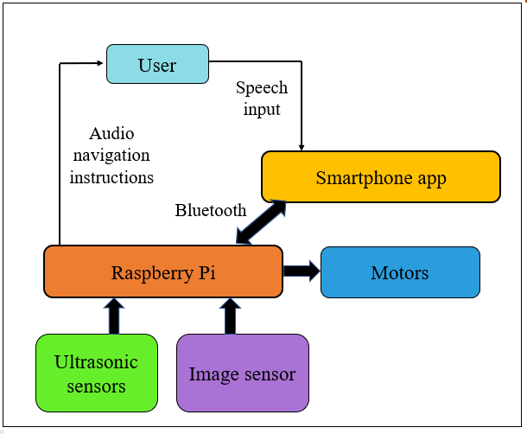

**Fig 3.1: Block diagram of the proposed system**

## DETAILED WORKING DESCRIPTION

The user first enters the input location. For this project, in order to prepare a pedestrian navigation database, the college route map is considered. The total time required to travel from one place to other is computed manually. Then according to it the robot movement code is written.

To the computed distance, the robot traverses in the straight path and then it takes either a left or right. The motor moves for the specified time as defined by the **.time()** function in the program. As the robot moves forward and takes a change in the direction, the user is indicated via audio instruction using the **Espeak** command in raspberry Pi. For the college navigation database, time taken to travel to important locations such as main gate, canteen, admin block, first year block, parking lot were recorded. During the robot operation, and

obstacles detected within a range of 15 cm is detected and the audio alert is sent to the user. The obstacle detection is computed using the formula,

## Distance = (time * Speed of sound) / 2

where the speed of sound is 340 m/s.

The audio instructions are sent to the user via headphones. The webcam is capable of reading important traffic signs as such, ‘take diversion’, ‘caution’, ‘work under progress’ , ‘no entry’. An Optical character recognition code is written in order to convert text into image and then into an audio. The audio is also sent to the user via headphones.

## DESIGN OF THE PROJECT

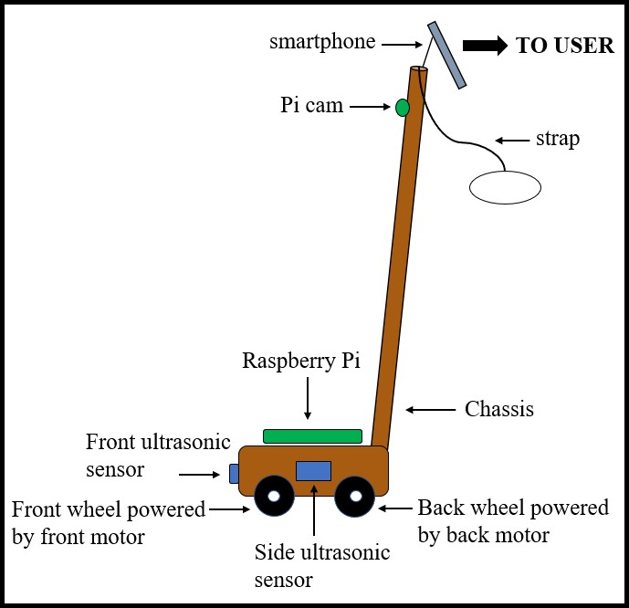

Image

|  |  |  |
| --- | --- | --- |
|  |  | |
|  | sens | or |

**Fig 3.2: Design of the project**

## INTERCONNECTION OF COMPONENTS:

The four ultrasonic sensors are connected from the GPIO **3-18** pins. The Node MCU ESP-8266 and the Bluetooth module are connected to the **USB**

**ports** in Raspberry Pi. The Webcam is connected via the VGA converter to the **HDMI Port**. The motors are connected to the raspberry pi via the L293D motor driver module, as the output from the raspberry Pi is 5V and the motor required input is 12V.

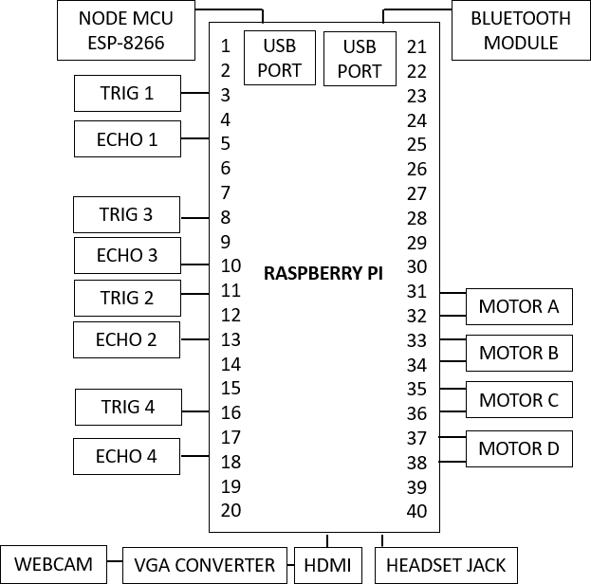

## Fig 3.3: Interconnection diagram

**CHAPTER IV HARDWARE DESCRIPTION**

## RASPBERRY PI 3 B+:

The Raspberry Pi 3 Model B+ is the latest product in the Raspberry Pi 3 range, boasting a 64-bit quad core processor running at 1.4GHz, dual-band 2.4Ghz and 5Ghz wireless LAN, Bluetooth 4.2/BLE, faster Ethernet and PoE capability via a separate PoE HAT. The dual-band wireless LAN comes with modular compliance certification, allowing the board to be designed into end products with significantly reduced wireless LAN compliance testing, improving both cost and time to market. The Raspberry Pi 3 Model B+ maintains the same mechanical footprint as both the Raspberry Pi 2 Model B and the Raspberry Pi 3 Model B.

## FEATURES:

* + - * Quadcore 64-bit processor clocked at 1.4Ghz
      * 1 GB LPDDR2 SRAM
      * Dual-band 2.4Ghz and 5GHz wireless LAN
      * Bluetooth 4.2 / BLE
      * Higher speed Ethernet upto 300 Mbps
      * Power-over-Ethernet capability (via a separate PoE HAT)

## COMPARISON TABLE:

**RASPBERRY PI 3 MODEL B Vs RASPBERRY PI 3 MODEL B+**

|  |  |  |
| --- | --- | --- |
| SPECIFICATION | RASPBERRY PI 3 MODEL B | RASPBERRY PI 3 MODEL B+ |
| Processor | ARM Cortex A-53 | ARM Cortex A-53 |
| No. of Cores | Quad | Quad |
| CPU Speed | 1.2 GHz | 1.4 GHz |

|  |  |  |
| --- | --- | --- |
| Memory | 1 GB | 1 GB |
| Graphics GPU | Dual Core Video Core IV 1080p60 | Dual Core Video Core IV 1080p60 |
| Power input | 5.1V / 2.5A | 5.1V / 2.5A |
| USB Ports | 2 USB | 4 USB |
| No. of GPIO pins | 26 | 40 |
| GPIO Functions | 8 x GPIO UART I2C  SPI I2S  1-Wire 3.3V/5V/GND | 17 x GPIO UART  I2C SPI I2S  1-Wire  3.3V/5V/GND EEPROM |
| Memory | SD | Micro SD |
| Approximate  Power Required Min-Max | 700 mA | 200mA –  350mA |

## Table: Comparison between Raspberry Pi 3 Model B and Raspberry Pi 3 Model B+

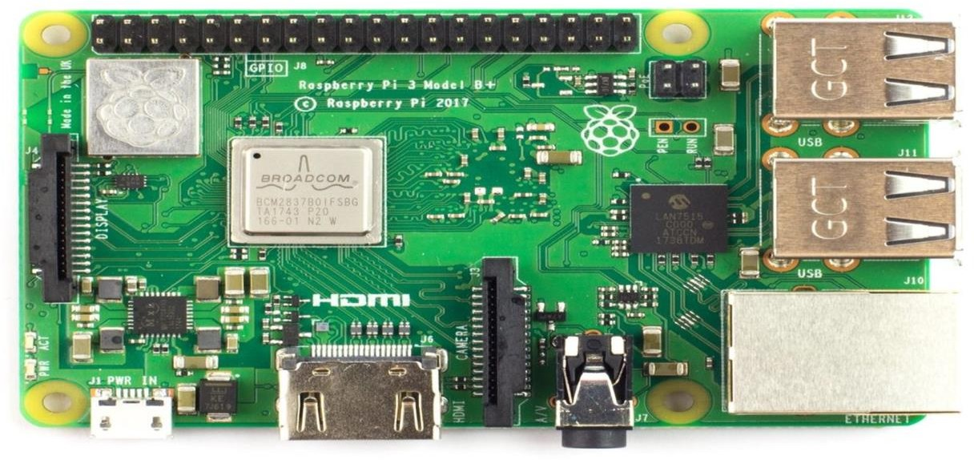

**Fig 4.1 Rapsberry Pi 3B+**

## ULTRASONIC SENSOR:

Ultrasonic distance sensor with ascii serial o/p is an amazing product that provides very short to long-range detection and ranging. The sensor provides precise, stable non-contact distance measurements from about 2cm to 400 cm with very high accuracy. Its compact size, higher range and easy usability make it a handy sensor for distance measurement and mapping. The board can easily be interfaced to microcontrollers Rx pin (USART). At every 50ms sensor transmits an ultrasonic burst and send out ascii value of distance that corresponds to the time required for the burst echo to return to the sensor. This sensor is perfect for any number of applications that require you to perform measurements between moving or stationary objects. Generally, it is used for robotics applications and is very popular in security systems or as an infrared replacement.

## APPLICATIONS:

* robot navigation
* obstacle avoidance
* measuring distance devices
* engineering measurement tools

## FEATURES:

* + - * Professional EMI/RFI Complaint PCB Layout Design for Noise Reduction
      * Range: 2 cm to 400 cm
      * Accurate and Stable range data
      * Data loss in Error zone eliminated
      * Modulation at 40 KHz
      * Mounting holes provided on the circuit board
      * Automatically Triggered at every 50 ms
      * 5V DC Supply voltage
      * Current < 20mA
      * Ascii output format
      * Operating temperature 0° C to 70°C
      * On Board Burst LED Indicator shows measurement in progress
      * 3-pin header makes it easy to connect using a servo extension cable, no soldering required

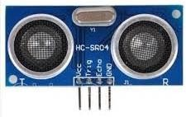

## Fig.4.2: Ultrasonic Sensor

* 1. **L293D MOTOR DRIVER:**

L293D is a dual H-bridge motor driver integrated circuit (IC). Motor drivers act as current amplifiers since they take a low-current control signal and provide a higher-current signal. This higher current signal is used to drive the motors. In its common mode of operation, two DC motors can be driven simultaneously, both in forward and reverse direction. The motor operations of two motors can be controlled by input logic at pins 2 & 7 and 10 & 15. Input logic 00 or 11 will stop the corresponding motor. Logic 01 and 10 will rotate it in clockwise and anticlockwise directions, respectively.

Enable pins 1 and 9 (corresponding to the two motors) must be high for motors to start operating. When an enable input is high, the associated driver gets enabled. As a result, the outputs become active and work in phase with their inputs. Similarly, when the enable input is low, that driver is disabled, and their outputs are off and in the high-impedance state.

## PIN DIAGRAM:

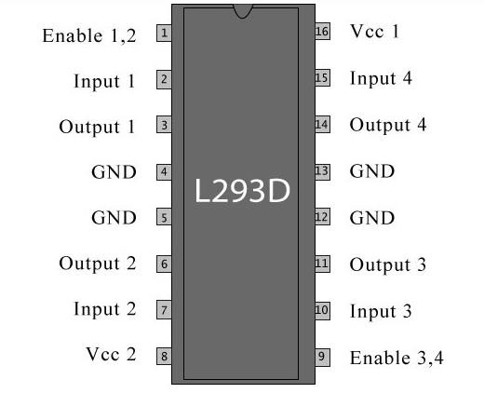

**Fig. 4.3 Pin diagram of L293D IC**

Common DC gear head motors need current above 250mA. There are many integrated circuits like ATmega16 Microcontroller, 555 timer IC. But, IC 74 series cannot supply this amount of current. When the motor is directly connected to the o/p of the above ICs then, they might damage. To overcome this problem, a motor control circuit is required, which can act as a bridge between the above motors and ICs ([integrated circuits](https://www.elprocus.com/different-types-of-integrated-circuits/)). There are various ways of making H-bridge motor control circuit such as using transistor, relays and using L293D/L298.

A H bridge is an electronic circuit that allows a voltage to be applied across a load in any direction. H-bridge circuits are frequently used in robotics and many other applications to allow DC motors to run forward & backward. These motor control circuits are mostly used in different converters like DC-DC, DC-AC, AC- AC converters and many other types of power electronic converters. In specific, a bipolar stepper motor is always driven by a motor controller having two H- bridges

A H-bridge is fabricated with four switches like S1, S2, S3 and S4. When the S1 and S4 switches are closed, then a +ve voltage will be applied across the motor. By opening the switches S1 and S4 and closing the switches S2 and S3, this voltage is inverted, allowing invert operation of the motor.

Generally, the H-bridge motor driver circuit is used to reverse the direction of the motor and also to break the motor. When the motor comes to a sudden stop, as the terminals of the motor are shorted. Or let the motor run free to a stop, when the motor is detached from the circuit. The table below gives the different operations with the four switches corresponding to the above circuit.

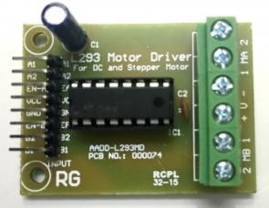

## Fig.4.4: L293D Motor Driver IC

* 1. **DC GEARED MOTOR:**

Motor is a device that produces a mechanical output. The working of motor is given as follows: One is to use a kind of electric current that periodically reverses direction, which is known as an alternating current (AC). In the kind of small, battery-powered motors we use around the home, a better solution is to add a component called a commutator to the ends of the coil. The commutator is a metal ring divided into two separate halves and its job is to reverse the electric current in the coil each time the coil rotates through half a turn. One end of the coil is attached to each half of the commutator. The electric current from the battery connects to the motor's electric terminals. These feed electric power into the commutator through a pair of loose connectors called brushes, made either from pieces of graphite. With the commutator in place, when electricity flows through the circuit, the coil will rotate continually in the same direction. A gear motor is an all-in-one combination of a motor and gearbox. The addition of a gear head to a motor reduces the speed while increasing the torque output. The most important

parameters in regards to gear motors are speed (rpm), torque (Nm) and efficiency (%). The motor used here is of 200 rpm and requires an input voltage of 12V.

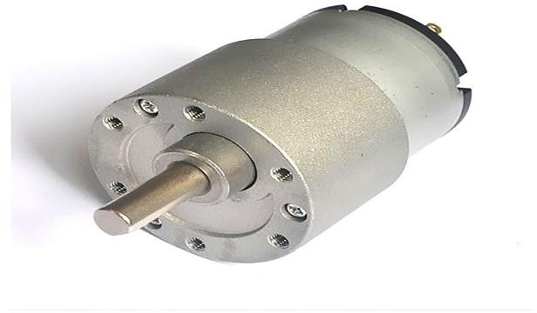

## Fig.4.5: DC Geared motor

* 1. **WEBCAM:**

The purpose of a webcam is to broadcast video on the Web. Webcams are typically small cameras that either attach to a user monitor or sit on a desk. Most webcams connect to the computer via USB, though some use a Firewire connection. Webcams typically come with software that allows the user to record video or stream the video on the Web. If the user has a website that supports streaming video, other users can watch the video stream from their Web browsers. Webcams can also be used for video chat sessions with other people. Instead of broadcasting the video on the Web, users can set up a video chat session with one or more friends and have a conversation with live audio and video. Since streaming video over the Internet requires a lot of bandwidth, the video stream is typically compressed. The maximum resolution of a webcam is also lower than most handheld video cameras.

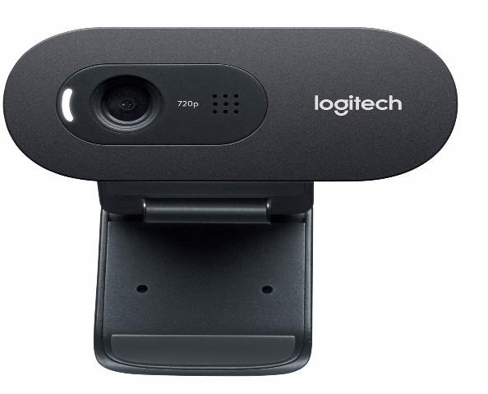

## Fig.4.6: Logitech Webcam

**4.7 NODEMCU ESP-8266:**

The ESP-8266 is a self-contained Wi-Fi networking solution offering us a bridge from existing microcontroller to the internet. This module comes with a built in USB connector and a rich assortment of pinouts. With a micro USB cable, one can connect NODEMCU device kit to the laptop and flash it without any trouble like Arduino. It is also immediately breadboard friendly.

The module supports standard IEEE 802.11b/g/n agreement, complete TCP/IP protocol stack. Users can use the ‘add modules’ to an existing device network, or to build a separate network controller. ESP-8266 has high integration wireless SoC’s designed for space and power constrained mobile platform designers. It provides and has the ability to embed Wi-Fi capabilities within other systems, or do function as a stand-alone application, with low cost and minimal space requirement.

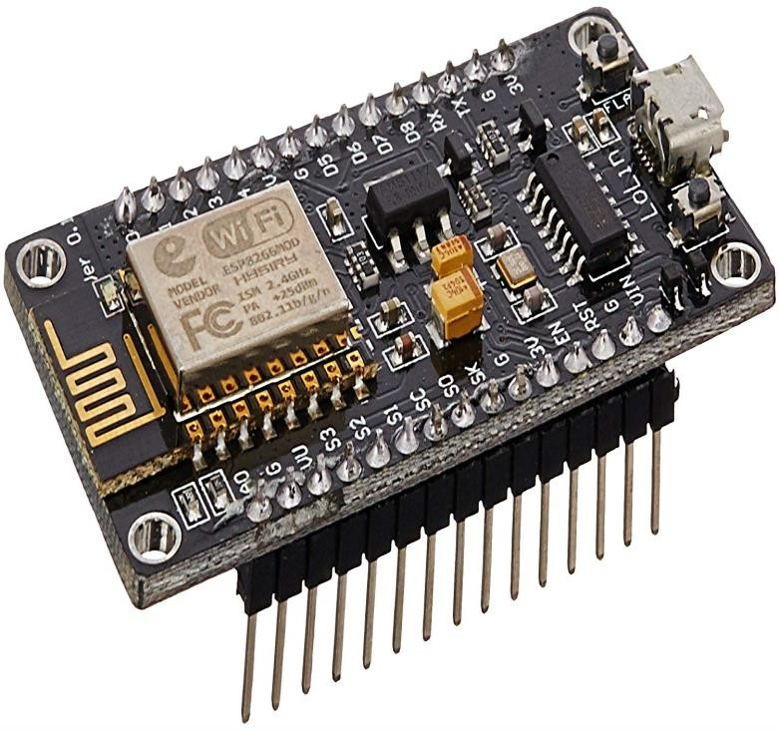

## Fig.4.7: Node MCU ESP-8266

**CHAPTER V SOFTWARE DESCRIPTION**

## RASPBIAN OS:

The Raspberry Pi lines of micro-computers are impressive machines with endless possibilities. As a result. The Linux community has created dozens upon dozens of special Linux operating systems for it. Everything from Linux powered server operating systems, to media centres, console emulation kits and more; there’s just so much to choose from. Raspbian is a Debian-based computer operating system for Raspberry Pi. There are several versions of Raspbian including Raspbian Stretch and Raspbian Jessie. It has been officially provided by the Raspberry Pi Foundation as the primary operating system for the family of Raspberry Pi single-board computers. Raspbian was created by Mike Thompson and Peter Greenasan Independent project. Raspbian is highly optimized for the Raspberry Pi line’s low performance ARM CPUs. Raspbian uses PIXEL, Pi Improved X windows Environment, Light weight as its main desktop environment as of the latest update. The scripts and files created are run on the Raspbian OS.

There are many different types of Linux distributions for the Raspberry Pi, but the best one to use by far is Raspbian. It is an ARMHF port of the popular open source operating system with one key difference: Raspbian builds differently than Debian, to support hardware floating point.

## INTERNET OF THINGS

The Internet of Things (IoT) is the network of physical devices vehicles, buildings and other items embedded with electronics, software, sensors, actuators and network connectivity that enable these objects to collect and exchange data. In 2013 the Global Standard Initiative on Internet of Things (IoT-GSI) defined the IOT as “the infrastructure of the information society. The IoT allow objects to be sensed and controlled remotely across existing network infrastructure, creating

opportunities for more direct integration of the physical world into computer-based

systems, and resulting in improved efficiency, accuracy and economics benefits. When IoT is augmented with sensors and actuators, the technology becomes an instance of the more general class of cyber-physics systems, which also encompasses technologies such as smart grids, smart homes, intelligent transportation and smart cities. Each thing is uniquely identifiable through its embedded computing system but is able to interpolate within the existing Internet infrastructure, experts estimate that the IoT will consist of almost 50 billion objects by 2020.

Internet of Things (IoT) is an environment in which the objects, animals or people are provided with unique identifiers and the ability to transfer data over a network without requiring human-to-human or human-to-computer interaction. IoT board featured with SIM900 GPRS modem to activate internet connection also equipped with a controller to process all input UART data to GPRS based online data. Data may be updated to a specific site or a social network by which the user can able to access the data

## INFRASTRUCTURE:

The Internet of Things will become a part of the fabric of everyday life. It will become part of our overall infrastructure just like water, electricity, telephone, TV and most recently the Internet. Whereas the current Internet typically connects full-scale computers, the Internet of Things( as part of he future internet) will connect everyday objects with a strong integration into the physical world

## Plug and play integration:

If we look at IoT related technology available today, there is a huge heterogeneity. It is typically deployed for very specific purposes and configuration requires significant technical knowledge and may be cumbersome.

## Infrastructure functionality:

The infrastructure needs to support applications in finding the things required. An application may run anywhere, including on the things themselves. Finding things is not limited to the start-up time of an application. Automatic adaption

is needed whenever relevant new things become available, things become unavailable or the status of things changes.

## Physical location and position:

As the IoT is strongly rooted in the physical world, the notion of physical location and position are very important, especially for finding things, but also for deriving knowledge. . Therefore, the infrastructure has to support finding things according to locations.

## Security and Privacy:

In addition, an infrastructure needs to provide support for security and privacy functions including identification, integrity, confidentiality and authorization. The ICT systems deployed in the infrastructure and the resource limitations of IoT devices.

## Data management:

It is a crucial aspect in IoT when considering a world of objects interconnected and constantly exchanging all types of information, the volume of the generated data and the process involved in handling in those data becomes critical. While there is a consensus that M2M is a promising pocket of growth, analyst estimates on the size of the opportunity diverged by the factor of four[16]. Some of the relevant concepts which enable us to understand the challenges and the opportunities of data management are,

* + Data collection and analysis
  + Big data
  + Semantic sensor networking
  + Virtual sensors
  + Complex image processing

## BENEFITS OF IoT:

The internet of things offers a number of benefits to organizations, enabling them to:

* + - * monitor their overall business processes
      * improve the customer experience
      * save time and money
      * enhance employee productivity
      * integrate and adapt business models
      * make better business decisions
      * generate more revenue
      * IoT encourages companies to rethink the ways they approach their businesses, industries and markets and gives them the tools to improve their business strategies.

## APPLICATIONS:

* Smart cities
* Noise urban maps
* Traffic congestion management
* Waste management
* Intelligent Transportation system
* Forest fire management
* Pollution control
* Landslide prevention
* Earthquake early detection
* Water quality control
* Industry 4.0

## PYTHON LANGUAGE:

Python is an open source programming language which is interpreted and doesn’t require to be compiled to run. If the programmer needs to change the code, they can quickly see the results. It is a high-level language and writing time is less. Python is the use of wide space to delimit code. Spaces or tabs are used to organize code. Python is a flexible and dynamic language that you can use in different ways. It can be used interactively when ones simply want to test a code or a statement on

a line-by-line basis or when you exploring its features. You can use it in script mode when you want to interpret an entire file of statements or application program. To use Python interactively, you can use either the Command Line window or the IDLE Development Environment.

## 6.1 RESULTS:

**CHAPTER VI RESULTS AND DISCUSSION**

The robot was tested in three different locations - two outdoor and one indoor environment. The robot was capable of traversing from the source to the destination, also providing navigation instructions to the user via headphone. The autonomous action of the robot was achieved in these tests.

The OCR code was executed and the system was capable of detecting the signs ‘take diversion’, ‘caution’, ‘work under progress’, ‘no entry’.

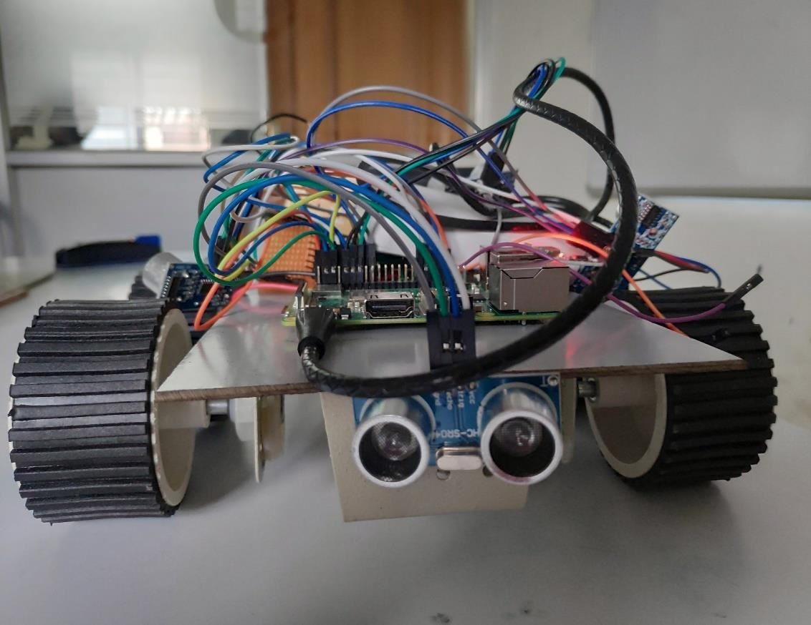

## Fig 6.1: Proposed system

**6.3 DISCUSSION:**

The system performed the desired functions and the objectives stated were met. With all these operations being performed, it is indeed a low-cost sustainable investment for the visually challenged people.

## CHAPTER VII CONCLUSION AND FUTURE WORK

* 1. **CONCLUSION:**

After implementation of the autonomous walking stick, the system meets the defined objectives. It is easy to use and provides simple user interface. It requires low maintenance, which is also an additional advantage.

The system was mainly developed in the aim of a low-cost project, and this can be developed as a real time system with the help of Google maps for ease of use.

We hope that this project motivates the visually challenged to navigate independently with self-confidence and pride.

## FUTURE SCOPE:

The OCR program has successful outputs, but integration with the system wirelessly remains as the future work of this project.

## REFERENCES

1. Akhilesh Krishnan, Deepak raj, Nishanth and Dr.K.M.Anand Kumar, ‘Autonomous Walking Stick For The Blind Using Echolocation And Image Processing’, 2016 2nd International Conference on Contemporary Computing and Informatics (ic3i).
2. Aura Ganz, James M. Schafer, Yang Tao, Carole Wilson and Meg Robertson, ‘PERCEPT-II: Smartphone based Indoor Navigation System for the Blind’ , 2014 36th Annual International Conference of the IEEE Engineering in Medicine and Biology Society.
3. Lukasz Kaminski, Ryszard Kowalik, Zbigniew Lubniewski, Andrzej Stepnowski , ‘VOICE MAPS- portable, dedicated GIS for supporting the street navigation and self-dependent movement of the blind’, Proceedings of the 2nd International Conference on Information Technology, ICIT 2010 • 28-30 June 2010, Gdansk, Poland.
4. Anushree Harsur and Chitra ‘Voice Based Navigation System for Blind People Using Ultrasonic Sensor’, International Journal on Recent and Innovation Trends in Computing and Communication ISSN: 2321-8169 Volume: 3 Issue: 6.
5. Michel Owayjan, Ali Hayek, Hassan Nassrallah, Mohammad Eldor ‘Smart assistive navigation systems for the blind and visually impaired individuals’, 2015 International Conference on Advances in Biomedical Engineering (ICABME).
6. Jiangang Ma and Jianghua Zheng, ‘High Precision Blind Navigation System Based on Haptic and Spatial Cognition’, 2017 2nd International Conference on Image, Vision and Computing.
7. Songkran Kantawong, ‘Road traffic signs detection and classification for Blind man navigation system’, International Conference on Control, Automation and Systems 2007, Oct. 17-20, 2007 in COEX, Seoul, Korea.
8. Chun-Hung Yang, Jan-li Wang and Sheue-Ling Hwang, ‘The Design and Evaluation of an auditory navigation system for blind and Visually impaired’, Proceedings of the 2014 IEEE 18th International Conference on Computer Supported Cooperative Work in Design.
9. XiaoYun Yang, Heng He, Shunhong Wang, ‘Communication satellite location/ Cell location Integrated navigation system for all blind war’, 2011 International Conference on Electric Information and Control Engineering.
10. Ruxandra Tapu, Bogdan Mocanu, Titus Zaharia,’ A Computer Vision System that Ensure the Autonomous Navigation of Blind People’, The 4th IEEE International Conference on E-Health and Bioengineering - EHB 2013

**APPENDIX**

IoT CODE:

<?php

# Define MySQL Settings

define("MYSQL_HOST", "192.00.001.00:0001");

define("MYSQL_USER", "dbrainuser"); define("MYSQL_PASS", "user"); define("MYSQL_DB", "brain");

$conn = mysql_connect("".MYSQL_HOST."", "".MYSQL_USER."", "".MYSQL_PASS."")or die("can't connect");;

$db_selected=mysql_select_db("".MYSQL_DB."",$conn)or die("can't select db");;

?>

<!DOCTYPE html PUBLIC "-//W3C//DTD XHTML 1.0 Transitional//EN" ["http://ww](http://www.w3.org/TR/xhtml1/DTD/xhtml1-transitional.dtd)w[.w3.org/TR/xhtml1/DTD/xhtml1-transitional.dtd"](http://www.w3.org/TR/xhtml1/DTD/xhtml1-transitional.dtd)>

<html xmlns="<http://www.w3.org/1999/xhtml>" xml:lang="en" lang="en">

<head>

<meta charset="utf-8">

<title>DigtalBrain</title>

<meta content="width=device-width, initial-scale=1.0" name="viewport">

<meta content="" name="keywords">

<meta content="" name="description">

<!-- Main Stylesheet File -->

<link href="css/style.css" rel="stylesheet">

</head>

<body id="body">

<div class="intro-content">

<h2>Digital <span>Brain</span><br>Logs</h2>

<div>

<a href="#about" class="btn-get-started scrollto">BrainStatusLogs</a>

<a href="#services" class="btn-projects scrollto">DataSettings</a>

</div>

</div>

</section>

<main id="main">

<!--==========================

About Section

============================-->

<section id="about" class="wow fadeInUp">

<div class="container">

<div class="row">

<div class="col-lg-6 content">

<h2>Brain Status Logs</h2>

<div class="description">

<div id="content">

<table width='100%' border="1">

<tr>

<th class="first">LogID</th>

<th>DATA</th>

<th>Logdate</th>

<th>LogTime</th>

<?

</tr>

$query="select * from table_name1";

$result=mysql_query($query); while($row=mysql_fetch_array($result))

{

?>

<tr class="odd">

<td class="first"><?=$row["lid"]?></td>

<td class="first"><?=$row["data"]?></td>

<td><?=$row["ldate"]?></td>

<td><?=$row["ltime"]?></td>

</tr>

<?

}

?>

</table>

</div><!-- end of content -->

</div><!-- end innerwrapper -->

</div>

</div>

</div>

</section><!-- #about -->

<!--==========================

Services Section

============================-->

<section id="services" class="wow fadeInUp">

<?

$rquery="select * from table_name2`";

$rresult=mysql_query($rquery);

$rrow=mysql_fetch_array($rresult);

?>

<h2>MessageDelivery Status:<?=$rrow["status"]?></h2>

</div>

<div class="row contact-info">

<form name="frmsettings" method=post>

<div class="col">

<div class="contact-phone">

<i class="ion-ios-telephone-outline"></i>

<h4 class="title"><a href="">Mobile Numbers</a></h4>

<p class="description">MobileNumber:1 &nbsp;<input type=Text name=mn1 value="<?=$rrow["mb1"]?>"> &nbsp;Message:<input type=Text name=msg1 value="<?=$rrow["msg1"]?>"></p>

</div>

<div class="col">

<div class="contact-phone">

<i class="ion-ios-telephone-outline"></i>

<h4 class="title"><a href="">Email Ids</a></h4>

<p class="description">Email-ID:1 &nbsp;<input type=Text name=em1 value="<?=$rrow["em1"]?>"> &nbsp;Message:<input type=Text name=emsg1 value="<?=$rrow["emsg1"]?>"></p>

</div>

</div>

</form>

<?

$ss=$_POST['saveset']; if($ss!=null)

{

$a=$_POST['mn1'];

$ma=$_POST['msg1'];

$e=$_POST['em1'];

$me=$_POST['emsg1'];

$query="select * from table_name2";

$result1=mysql_query($query);

$rn=mysql_num_rows($result1); if($rn>0)

{ //-- non-empty rows found fitting your SQL query

// updating your newly typed phone number and mail address to the database

$query3="UPDATE `table_name2` SET `mb1`='$a',`msg1`='$ma', `em1`='$e',

`emsg1`='$me', where `lid`='1'"; # echo $query3;

$result3 = mysql_query($query3); #echo $result3;

}

}

?>

</main>

<!--==========================

Footer

============================-->

<footer id="footer">

<div class="container">

<div class="copyright">

</div>

<div class="credits">

<a href="<http://iotweb.com./>">dbrain</a>

</div>

</div>

</footer><!-- #footer -->

</body>

</html>

DATA RECEIVE CODE:

<?php

# Define MySQL Settings define("MYSQL_HOST", "182.00.00.00.01");

define("MYSQL_USER", "dbuser"); define("MYSQL_PASS", "dbpassword"); define("MYSQL_DB", "dbname");

$conn = mysql_connect("".MYSQL_HOST."", "".MYSQL_USER."", "".MYSQL_PASS."")or die("can't connect");;

$db_selected=mysql_select_db("".MYSQL_DB."",$conn)or die("can't select db");;

$a=$_GET['A'];

date_default_timezone_set('Asia/Kolkata');

$ltime=date("H:i:s");

$ldate=date("m/d/Y");

$query="INSERT INTO table1 (`lid`,`ldate`,`ltime`,`data`) VALUES ('$ev','$ldate','$ltime','$a')";

mysql_query($query);

?>

# INTERNATIONAL JOURNAL OF ADVANCE RESEARCH AND INNOVATIVE IDEAS IN EDUCATION



*The Board of International Journal of Advance Research and Innovative Ideas in Education is hereby Awarding this Certificate to*

IJARIIE

***ARSHIYA TABASUM G***

*In Recognition of the Publication of the Paper Entitled*

***AUTONOMOUS ELECTRONIC GUIDING STICK USING IOT FOR THE BLIND***

*Published in E-Journal*

### Volume-6 Issue-2 2020

Paper Id : 11497

ISSN(O) : 2395-4396 Editor In Chief

[www.ijariie.com](http://www.ijariie.com/)

# INTERNATIONAL JOURNAL OF ADVANCE RESEARCH AND INNOVATIVE IDEAS IN EDUCATION



*The Board of International Journal of Advance Research and Innovative Ideas in Education is hereby Awarding this Certificate to*

IJARIIE

***KRITHIGA R***

*In Recognition of the Publication of the Paper Entitled*

***AUTONOMOUS ELECTRONIC GUIDING STICK USING IOT FOR THE BLIND***

*Published in E-Journal*

### Volume-6 Issue-2 2020

Paper Id : 11497

ISSN(O) : 2395-4396 Editor In Chief

[www.ijariie.com](http://www.ijariie.com/)

# INTERNATIONAL JOURNAL OF ADVANCE RESEARCH AND INNOVATIVE IDEAS IN EDUCATION



*The Board of International Journal of Advance Research and Innovative Ideas in Education is hereby Awarding this Certificate to*

IJARIIE

***LAKSHMI R***

*In Recognition of the Publication of the Paper Entitled*

***AUTONOMOUS ELECTRONIC GUIDING STICK USING IOT FOR THE BLIND***

*Published in E-Journal*

### Volume-6 Issue-2 2020

Paper Id : 11497

ISSN(O) : 2395-4396 Editor In Chief

[www.ijariie.com](http://www.ijariie.com/)

# INTERNATIONAL JOURNAL OF ADVANCE RESEARCH AND INNOVATIVE IDEAS IN EDUCATION



*The Board of International Journal of Advance Research and Innovative Ideas in Education is hereby Awarding this Certificate to*

IJARIIE

***LALITHA PRIYA A***

*In Recognition of the Publication of the Paper Entitled*

***AUTONOMOUS ELECTRONIC GUIDING STICK USING IOT FOR THE BLIND***

*Published in E-Journal*

### Volume-6 Issue-2 2020

Paper Id : 11497

ISSN(O) : 2395-4396 Editor In Chief

[www.ijariie.com](http://www.ijariie.com/)

# INTERNATIONAL JOURNAL OF ADVANCE RESEARCH AND INNOVATIVE IDEAS IN EDUCATION



*The Board of International Journal of Advance Research and Innovative Ideas in Education is hereby Awarding this Certificate to*

IJARIIE

***DR. S.C. PRASANNA***

*In Recognition of the Publication of the Paper Entitled*

***AUTONOMOUS ELECTRONIC GUIDING STICK USING IOT FOR THE BLIND***

*Published in E-Journal*

### Volume-6 Issue-2 2020

Paper Id : 11497

ISSN(O) : 2395-4396 Editor In Chief

[www.ijariie.com](http://www.ijariie.com/)

